TFL Bus Speed & Reliability Analysis
2026
Mahroze Adnan

9/7/2026
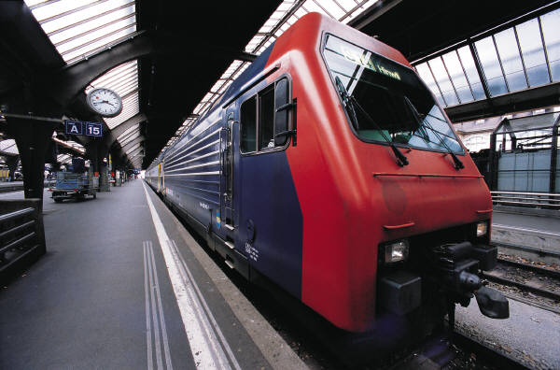

Table of Contents
1. Project Overview 3
2. Business Problem 3
3. Data & Methodology 3
I. Data source 3
III. Data preparation 4
4. Key Measures 4
➢ Average Bus Speed 4
➢ Maximum Bus Speed 4
➢ Minimum Bus Speed 4
➢ Speed Range 4
5. Dashboard Analysis 5
o Overall Average Bus Speed 5
o 10.3 mph 5
o 10 Slowest Bus Routes 5
o Yearly Speed Comparison 6
o Average Bus Speed by Reporting Period 6
o 10 Most Variable Bus Routes 7
6. Key Findings 8
7. Business Recommendations 8
1. Investigate consistently slow routes 8
2. Investigate highly variable routes 8
3. Monitor performance over time 8
4. Combine speed data with additional datasets 8
8. Limitations 9
➢ Speed is not the same as reliability 9
➢ Causes cannot be established 9
➢ Additional data would improve the analysis 9
9. Tools Used 9
10. Final Project Statement 9

Table of Figures
Figure 1: Overall Average Bus Speed 6
Figure 2: 10 Slowest Bus Route by Average Speed 7
Figure 3: Yearly Speed Comparison 7
Figure 4: Average Bus Speed by Reporting Period 8
Figure 5: 10 Most Variable Bus Speed Route 8

Project Overview
This project analyses Transport for London (TfL) bus speed data to identify routes and reporting periods associated with slower or more variable bus performance.
The analysis uses historical bus speed observations across multiple reporting periods and years. Power BI was used to transform the data into an interactive analytical dashboard, focusing on identifying potential areas where bus performance could be investigated further.
The project was designed around a practical business question:
Which bus routes and periods show slower or more inconsistent bus speed patterns, and where should further investigation be prioritised?

Business Problem
Bus performance can vary considerably between routes and over time. Identifying routes with consistently low or highly variable speeds can help transport planners understand where further investigation may be required.
The analysis aims to answer:
- Which bus routes have the lowest average speeds?
- How do these routes perform across different years?
- How does average bus speed change across reporting periods?
- Which routes experience the greatest variation in recorded speeds?
- Where should TfL potentially prioritise further investigation?
The objective is not to identify the causes of slow speeds, as the dataset does not contain sufficient information to establish causality. Instead, the analysis identifies patterns and potential areas for operational investigation.

Data & Methodology

Data source
The project uses TfL's Bus Speeds Report data.
The dataset contains bus speed observations measured in miles per hour (mph) across different bus routes and reporting periods.
The analysis combined data from multiple annual reporting periods so that historical comparisons could be performed.

- Key fields
The analysis uses:
- Route
- Period
- Year
- Mean Bus Speed
- Period Number
- Reporting Period

Data preparation
Power Query was used to prepare the data for analysis.
The main preparation steps included:
- Importing the annual TfL bus speed datasets.
- Removing unnecessary rows and columns.
- Standardising column names.
- Converting appropriate fields to suitable data types.
- Reshaping the reporting-period columns into a structured format.
- Combining multiple years into a single dataset.
- Creating a numerical period field for analysis.
- Creating a reporting-period field to support chronological analysis.
- Handling invalid/missing speed observations where required.
- Creating calculated measures in Power BI.

Key Measures
Several DAX measures were created to support the analysis.
- Average Bus Speed
Average Bus Speed =
AVERAGE('Bus Speed Data'[Mean Bus Speed])
- Maximum Bus Speed
Maximum Bus Speed =
MAX('Bus Speed Data'[Mean Bus Speed])
- Minimum Bus Speed
Minimum Bus Speed =
MIN('Bus Speed Data'[Mean Bus Speed])
- Speed Range
Speed Range =
[Maximum Bus Speed] - [Minimum Bus Speed]
The Speed Range measure was particularly useful for identifying routes with greater variation in recorded bus speeds.

Dashboard Analysis
The final Power BI dashboard contains four main analytical views and an overall KPI.

Overall Average Bus Speed
The dataset has an overall average bus speed of approximately:

10.3 mph
This provides a benchmark against which route and period-level performance can be considered.
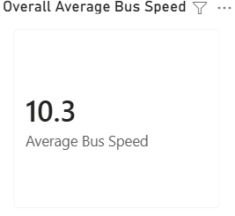
Figure 1: Overall Average Bus Speed

10 Slowest Bus Routes
The dashboard identifies the ten routes with the lowest overall average bus speeds.
This provides a starting point for identifying routes that may require further investigation.
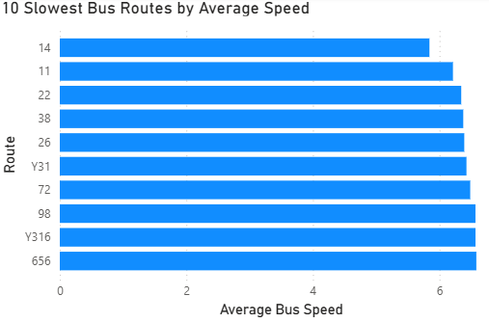
Figure 2: 10 Slowest Bus Route by Average Speed

Yearly Speed Comparison
The slowest routes are compared across the available years.
This helps distinguish between routes that consistently record lower speeds and routes where performance varies between years.
For example, some routes show relatively similar speeds across multiple years, while others display greater year-to-year variation.
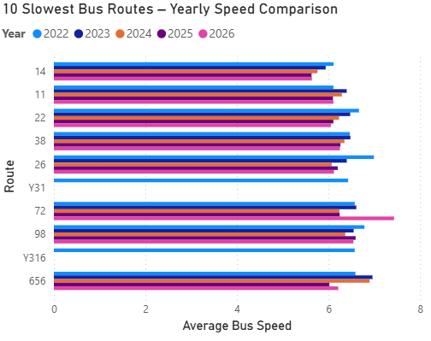
Figure 3: Yearly Speed Comparison

Average Bus Speed by Reporting Period
The reporting-period trend demonstrates that average bus speeds fluctuate over time.
The network does not maintain a constant average speed, with some reporting periods showing noticeable increases or decreases.
This provides an opportunity to investigate whether external factors, road conditions, congestion or operational changes may correspond with these periods.
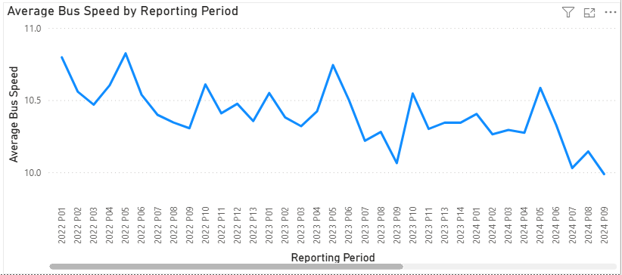
Figure 4: Average Bus Speed by Reporting Period

10 Most Variable Bus Routes
The Speed Range measure was used to identify routes with the largest difference between their highest and lowest recorded speeds.
Route 399 stands out as having a substantially larger speed range than the other routes analysed.
This makes it a potential candidate for further investigation into the reasons behind its variation in recorded speeds.
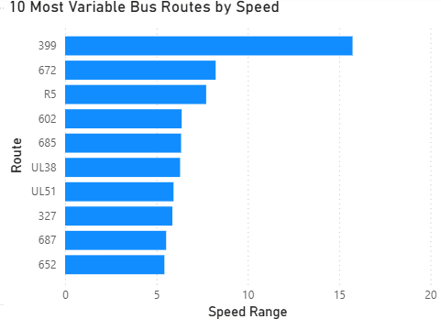
Figure 5: 10 Most Variable Bus Speed Route

Key Findings
The analysis identified several important patterns:
- The overall average bus speed across the analysed data is approximately 10.3 mph.
- A number of routes consistently appear among the slowest-performing routes.
- Bus speeds vary between reporting periods rather than remaining constant.
- Year-on-year comparisons show that some routes experience relatively stable performance while others show greater variation.
- Route 399 has the largest speed range among the routes identified in the variability analysis.
- The analysis highlights specific routes and periods that could be prioritised for deeper operational investigation.

Business Recommendations
Based on the analysis, the following actions could be considered:

1. Investigate consistently slow routes
TfL could prioritise the slowest-performing routes for further investigation to understand whether congestion, road layouts, bus-stop activity or other operational factors are contributing to lower speeds.

2. Investigate highly variable routes
Routes such as 399, which demonstrate a large speed range, could be examined to understand why performance varies considerably between observations.

3. Monitor performance over time
Reporting-period trends could be monitored to identify recurring periods of declining bus speeds.

4. Combine speed data with additional datasets
Speed analysis would become more actionable when combined with information such as:
- traffic congestion
- roadworks
- journey times
- passenger demand
- bus-stop locations
- timetable adherence
- weather
- incidents
This would allow TfL to move from identifying where performance changes to investigating why it changes.

Limitations
There are several limitations to this analysis.

Speed is not the same as reliability
The dataset measures bus speed, rather than TfL's formal reliability measures such as timetable adherence or excess waiting time.
Therefore, this project should be described as a bus speed and reliability analysis, rather than claiming to directly measure formal bus reliability.

Causes cannot be established
The dataset allows us to identify patterns in bus speeds but does not explain why speeds increase or decrease.
Therefore, the analysis identifies areas for investigation rather than causal explanations.

Additional data would improve the analysis
Combining the dataset with congestion, roadworks, passenger demand and operational data would provide a much stronger basis for determining the causes of poor performance.

Tools Used
- Microsoft Power BI
- Power Query
- DAX
- Microsoft Excel
- Data visualisation
- Data cleaning and transformation
- GitHub

Final Project Statement
This project demonstrates how data analysis can be used to identify potential operational issues within a large transport network. Rather than simply presenting bus speed statistics, the analysis focuses on identifying slow and highly variable routes and highlighting where further investigation could provide the greatest operational value

